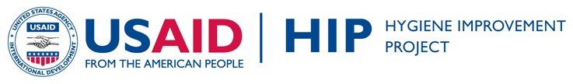
WASH & HIV/AIDS INTEGRATION:
TRAINING AND SUPPORT
HANDWASHING

The following participants guide was developed as part of HIPs country programming in Uganda. It contains only those sections relevant to handwashing.

The entire training package from Uganda (with information all key WASH behaviors), including counseling cards, the trainer’s manual and training handouts, are a part of HIP’s WASH HIV Integration Toolkit, which can be found at http://www.hip.watsan.net/page/4489. To access other program documents, such as research reports, please visit: http://www.hip.watsan.net/page/3586
Please note that because the following pieces were taken from a larger document and some sections have been removed, the numbering of the various sections matches the original document and is therefore not always consecutive.
PARTICPANTS GUIDE: Handwashing

Improving Water,
Sanitation, and Hygiene
(WASH) Practices of
Uganda Home-Based
Care Providers, their
Clients, and Caregivers
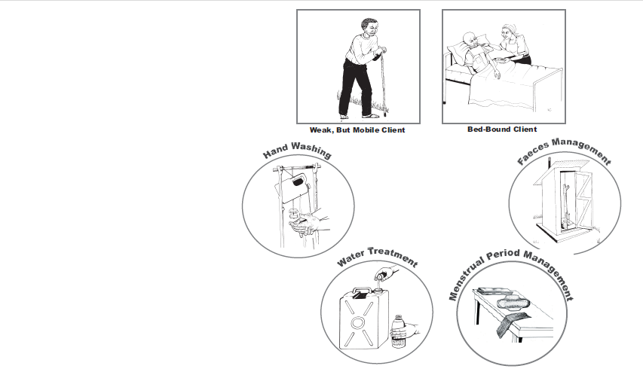
in the Home

The USAID Hygiene Improvement Project (HIP) is a six-year (2004-2009) project
funded by the USAID Bureau for Global Health, Office of Health, Infectious Diseases
and Nutrition, led by the Academy for Educational Development (contract # GHS-I-
00-04-00024-00) in partnership with ARD Inc., the IRC International Water and
Sanitation Centre in the Netherlands, and The Manoff Group. HIP aims to reduce
diarrheal disease prevalence through the promotion of key hygiene improvement
practices, such as hand washing with soap, safe disposal of feces, and safe storage
and treatment of drinking water at the household level.

Contact Information:  USAID Hygiene Improvement Project  Academy for Educational Development  1825 Connecticut Avenue, NW  Washington, DC 20009-5721  Tel. 202-884-8000; Fax: 202-884-8454  hip@aed.org - www.hip.watsan.net | Plan – Uganda  Plot 126 Luthuli Avenue, Bugolobi,  P.O. Box 12075  Kampala, Uganda  www.plan-international.org  Office Telephone: + 256-414-305-000

Acknowledgements
The primary authors of this document were: Julie Chitty (International HIV/AIDS Consultant, HIP), Elizabeth Younger (Senior Behaviour Change Advisor, HIP), Lucy Korukiiko (HIP HIV/AIDS Consultant, Uganda), Carol Nabalema (HIP Coordinator, Uganda), Judith Rukirande (HIP Training Consultant, Uganda), and Justin Igala (illustrator, Uganda).
Development of this training program required extensive collaboration of various organisations, agencies, and individuals and could not have been done without their continuous contribution and tireless work. The Ugandan Ministry of Health, the USAID Hygiene Improvement Project, Plan International - Uganda, the Uganda Water and Sanitation NGO Network (UWASNET) and the National Working Group on WASH Integration into Home Based Care in Uganda, wish to acknowledge the various organisations and their key staff members who contributed time, expertise, hard work and experience to produce this document. They include: Barbara Mukasa from the Mildmay Centre, Charlotte Komunda from Hospice Africa Uganda, Jacinta Magero from the National Community of Women Living with HIV/AIDS (NACWOLA), Phoebe Kansinga from Nsambya Home Care, Mary Amony and Joseph Ssali from Reach Out Mbuya, Esther Karamagi from PSI, Hannart Nalweyiso and Dennis Alioni from The National Handwashing Campaign, and Domitilla Aginya Odongo from the Ministry of Health.
We greatly appreciate efforts of individuals from the previously mentioned organisations and the International HIV/AIDS Alliance (IHAA) who actively participated in piloting the developed tools at household and community levels and continually gave feedback to the HIP team. HIP will always appreciate their enormous contribution and assistance. They included; Francis Ssozi, Namazzi Josephine, Kiwanuka Edson, Acenge Eunice, Nandita Daisy, Nazziwa Yudaya, Namugerwa Rose, Ndagiire Sarah, Hajat Kakoma, Dorcus Achom, Edward Kato, Christine Achire, Amony Grace, Byamukama Charles, Richard Sserunjogi, Beatrice Juru Bungu, Martha Rabwoni, Nsiimenta Rosemary, Kamonyo Eddie, and Aloysius Nkangi.
Special thanks go to the field assistants who pre-tested the images, communities and families in Uganda for their support and cooperation during the initial phase of this work, which made the production of these materials possible. The Ugandan Ministry of Health, the USAID Hygiene Improvement Project, Plan International - Uganda, UWASNET, and the National Working Group on WASH Integration into Home Based Care in Uganda would also like to thank USAID for providing funding and technical assistance during the development process.

Table of Contents

Introduction ........................................................................................ 9
How to Use the Participant’s Guide...................................................... 9

Unit 1: Basic Facts about “WASH” and Home-Based Care............ 13
- Introduction to Water, Sanitation and Hygiene (WASH) ........ 13
- How Poor WASH Practises Cause Diarrhoea ........................ 16
- Facts About HIV and Water, Sanitation and Hygiene (WASH) .................................................................................. 17

Unit 2: Hand Washing ........................................................................ 22
- Why You Should Wash Your Hands....................................... 22
- How to Wash Your Hands with Soap (or Ash)........................ 22
- What You Need to Wash Your Hands .................................... 24
- When You Wash Your Hands................................................. 24
- Who Should Wash Their Hands? .......................................... 26
- Hand Washing Station............................................................ 26
- Tippy Taps for Hand Washing ................................................ 28

Annexes .............................................................................................. 35

Introduction

How to Use the Participant’s Guide
The purpose of this guide is to give Home Based Care (HBC) Providers the tools and information they need to improve the quality of care they provide to their clients. In particular, this Guide focuses on how to improve care related to:
- Water: How to make water safer to drink by safely transporting, storing and serving it, and by adding chemicals (chlorinating water) or by boiling it. This is called “treating” water.
- Faeces: How to properly handle and dispose of faeces, which is often called proper sanitation.
- Handwashing: how to properly wash hands and when to wash hands, which is often called proper hygiene.

The three subject areas of water, sanitation and hygiene are often referred to with the initials/acronym of WASH.
The Guide also includes tools and information that HBC Providers can use to help their clients and their client’s household members improve their WASH practises, or the way in which they customarily wash their hands; treat, transport, store and serve their drinking water; and handle and dispose of faeces and menstrual blood.
When water is treated, transported, stored and served properly, and people wash their hands and eliminate faeces and menstrual blood properly, fewer germs are spread. This results in fewer cases of diarrhoea and other illnesses, which has a positive effect on HBC providers, caregivers and other household members by improving their health. When people are healthy, they do not spend money on medicine and doctor visits, they can work without problems, and children do not miss school. All of this leads to the improvements in the home based care client’s condition, the family’s living conditions and the quality of the services provided by the HBC Providers.
This Guide provides practical information, illustrations and tools to help clients, family members and HBC providers make informed decisions about water, sanitation and hygiene practises which directly impact the health of the household.
The Annexes in the back include:
- Annex 1: An acronym and glossary section that explains terms, basic definitions and acronyms that will be used throughout the participant’s guide and training course. If you do not understand the meaning of words or abbreviations in this guide, please look for more information in this Annex.
- Annex 2: Tools to help improve WASH practices, including:
- Tool 1: Interpersonal communication skills
- Tool 2: The four “A” steps
- Tool 3: How to use the WASH assessment tool
- Tool 4: How to use the WASH counselling cards
- Tool 5: Supplies for WAH in home based care

Practical Topics and Tools for HBC Providers, Clients and their caregivers in the home

Unit 1: Basic Facts about “WASH” and Home-based Care

1. Introduction to Water, Sanitation and Hygiene (WASH)

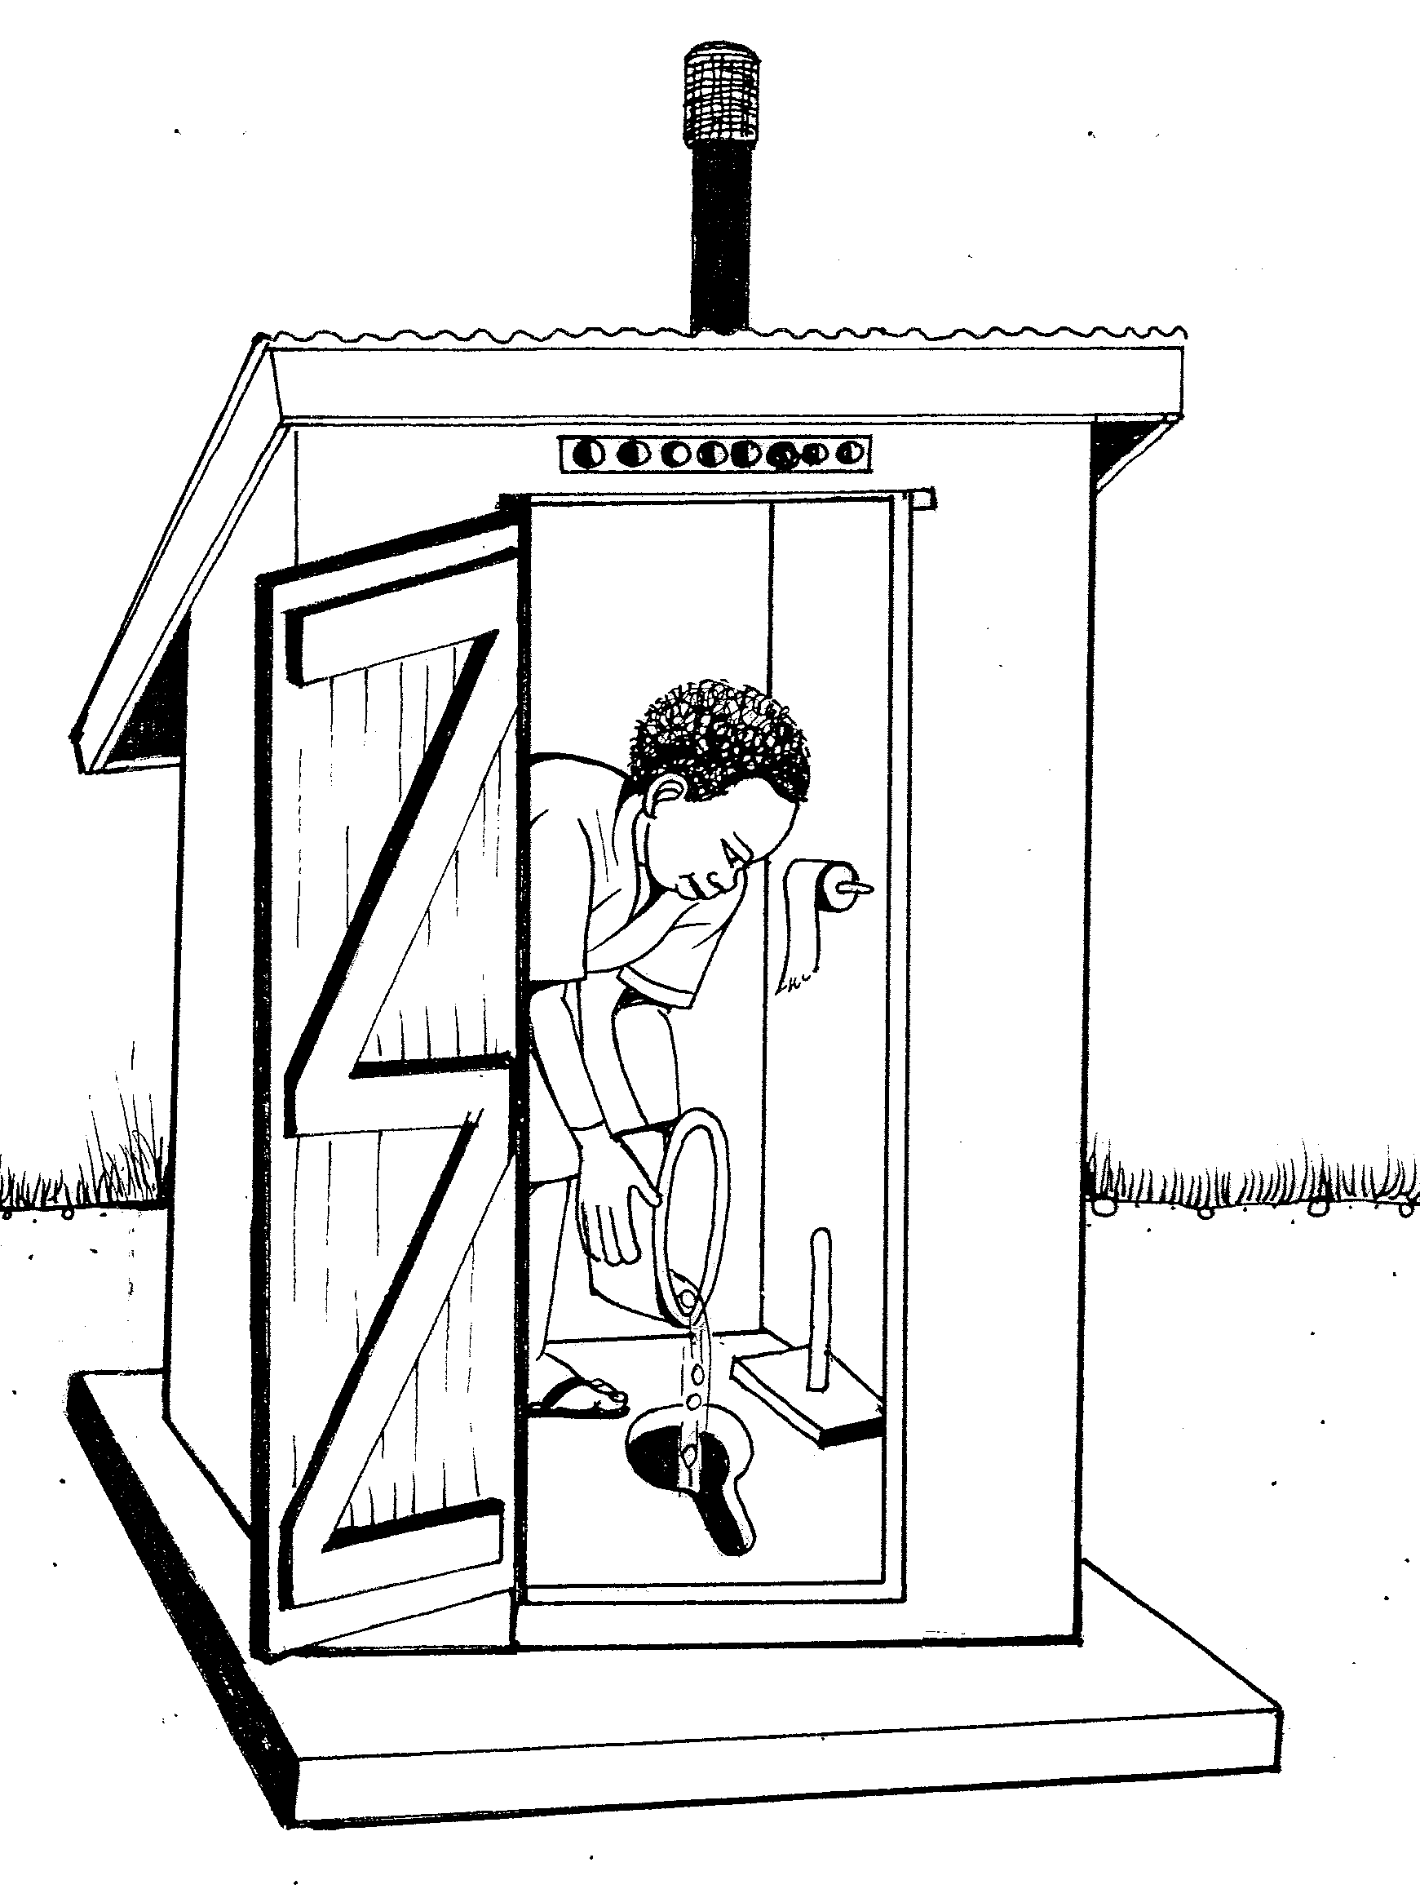
Research in households in Uganda identified that there are problems in the way that many households and HBC providers wash their hands, treat and handle their water, and handle their faeces and menstrual blood, especially for people who are ill, weak and bedbound.
These poor practises can lead to conditions that raise the risk of getting diarrhoea and transmitting illnesses, like HIV, from one person to another. This Participant’s Guide is focused on building on what HBC providers and household members already know to help improve four key WASH practises in households, including:
- Handwashing with soap (or ash) and water;
- Treating, safely transporting, storing and serving drinking water;
- Safe handling and disposal of faeces;
- Safe handling and disposal of menstrual blood.

Poor water, sanitation and hygiene practises cause many problems for the household, including:
- Diarrhoea and other serious illnesses. Diarrhoea is a very common illness and is a sign of disease in the body. Severe diarrhoea can cause:
  - A loss of fluids (water) in the body called dehydration. The lack of water can be especially serious in children, the elderly, those living with illnesses and those who are malnourished. Any person with diarrhoea is in danger of dehydration.
  - Malnutrition and delayed growth of people, especially children. Bad nutrition can also lead to more diarrhoea illness.
  - Poor quality of life of people, or the ability to enjoy normal life activities.
  - Money problems in the household. With diarrhoea in the household, more money is spent to treat diseases and household members have less ability to work on days that they (or their children) are sick.

- Slow development of children and poor school attendance and performance. Many children suffer from stomach infections caused by parasites as a result of poor water, sanitation and hygiene. These parasites can slow a child's development and result in poor school attendance and performance. Poor WASH facilities in schools also discourage girls from attending school full time and force some to drop out.

- Opportunistic infections among people living with HIV and AIDS. An opportunistic infection is an infection caused by germs that usually do not cause disease in a healthy immune system (the body’s natural defence system against illness). When someone is living with HIV, they have a poor immune system that presents an easy "opportunity" for a germ to infect and cause illness that can easily be prevented. This is especially important because people living with HIV and AIDS die of opportunistic infections, not from the HIV itself. Good water, sanitation and hygiene (WASH) practises can help prevent opportunistic infections such as diarrhoea, mouth diseases and skin conditions.

- Spread of HIV by unsafely handling and disposing of items soaked with the menstrual blood of HIV-positive female clients. Menstrual blood of HIV-positive female clients can contain HIV. However, there is an extremely low risk of getting HIV when handling items soaked with menstrual blood if universal precautions are taken. Universal precautions are simple infection control procedures (e.g. washing and protecting your hands, etc) that reduce the risk of spreading infectious germs among clients, the client’s household members and HBC providers. Universal precautions are meant to not only protect HBC providers and family members, but also protect the clients from unnecessary infection. It is important that HBC providers take universal precautions with ALL of their clients, whether they know if they are HIV positive or not.

2. How Poor WASH Practises Cause Diarrhoea
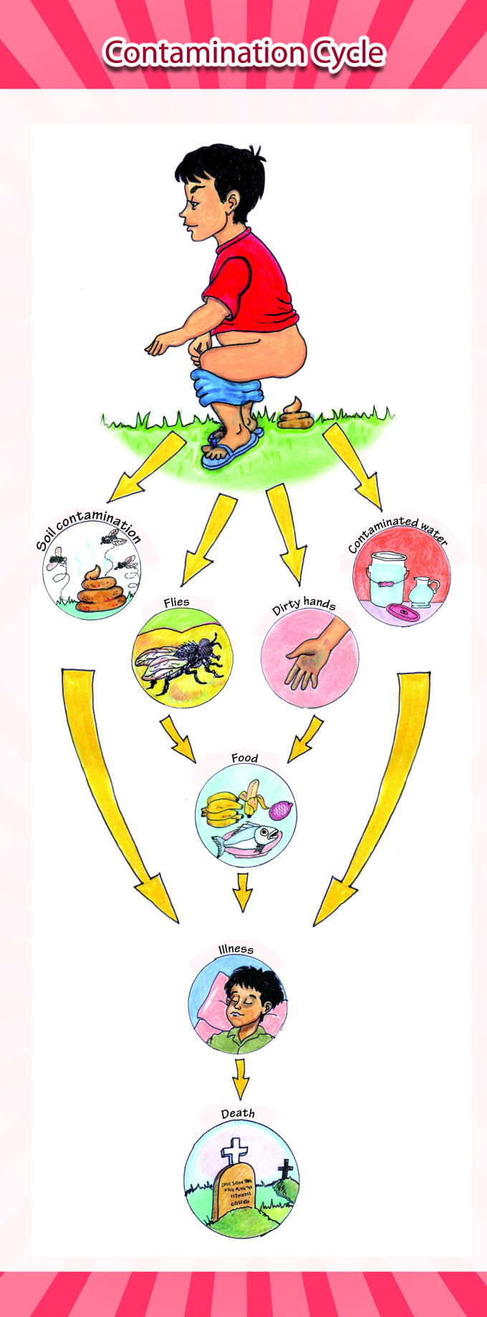
Most diarrhoea is caused by eating food or drinking water that is contaminated or infected with human and/or animal faeces as a result of poor sanitation, poor hygiene and unsafe drinking water. This is illustrated in the contamination cycle diagram.
This diagram shows the way that germs that cause diarrhoea mainly reach people including via “the 5 F’s”: fingers (hand), flies (insects), fields (defecation outdoors), fluids (water supply) or food, or directly into the mouth.
- The contamination cycle starts with people (represented here by a child) and animals defecating out in the open.
- Faeces come into contact with the soil and contaminates people and animals.
- Faeces on the ground attract flies, and flies contaminated with faeces land on food, which people eat.
- People who do not wash their hands after defecating spread germs in their surroundings and food.
- Faeces in the soil contaminate our water sources and then we consume contaminated water.

Contamination by all of these routes occurs every day in our community and causes diarrhoea, especially affecting children and people whose immune systems are already weak such as the elderly and those who are living with HIV. Certain hygiene practises have been proven to have the greatest potential for preventing diarrhoea because they reduce the transmission of germs. They are:
- Safe handling and disposal of faeces
- Correct handwashing and at critical times
- Safe drinking water: treatment and safe transportation, storage and serving.

3. Facts About HIV and Water Sanitation and Hygiene (WASH)
Because HIV lives in certain body fluids (e.g. blood, faeces with blood, vaginal fluids, semen, breast milk, pus, blister fluid) and affects the way HIV-positive clients may handle their water, sanitation and hygiene needs, it is important to remember some key facts when you are providing care to HIV-affected households:
People living with HIV can experience diarrhoea more frequently than people who are not living with HIV.
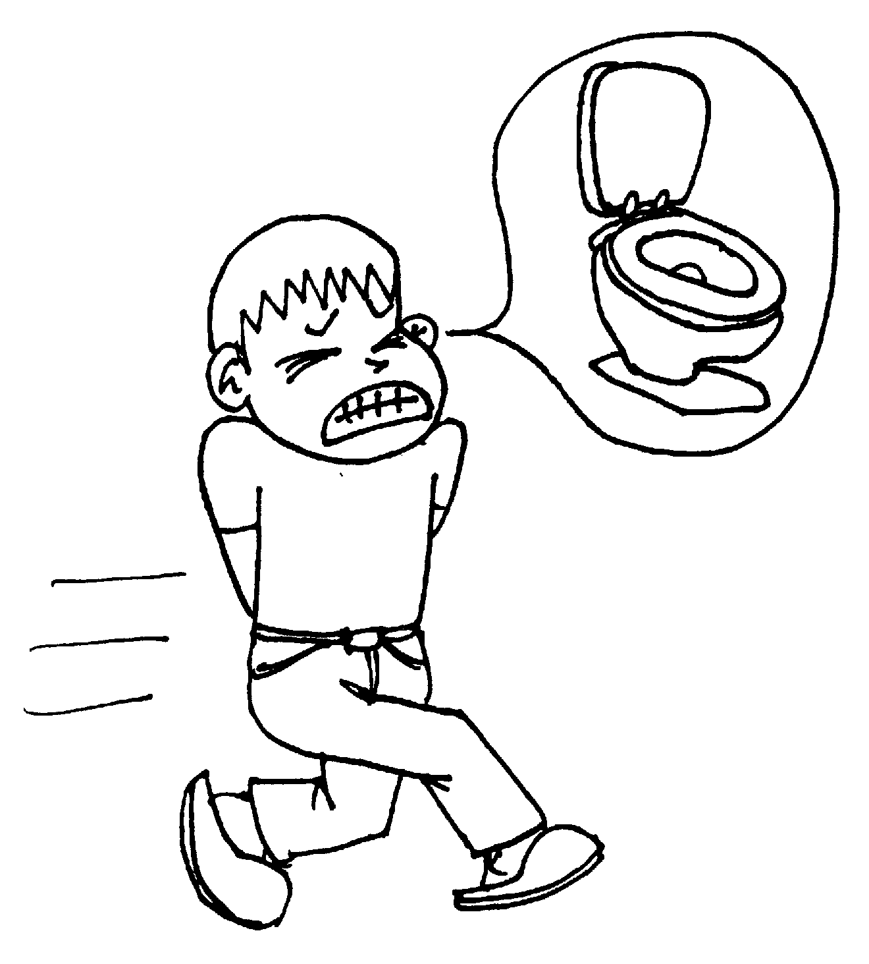 | 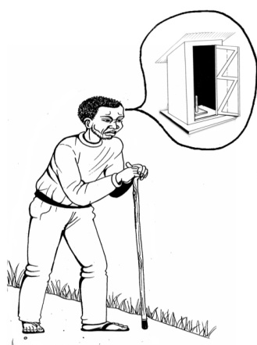

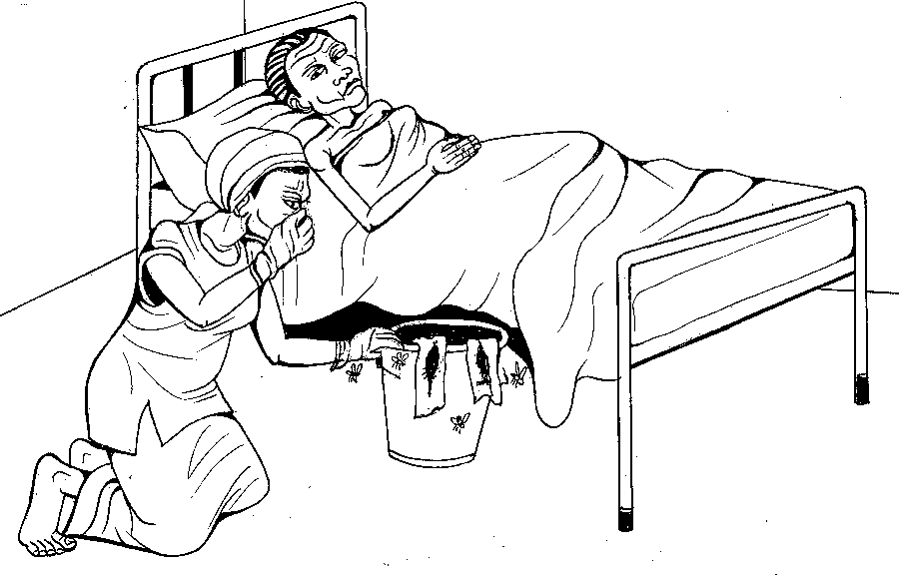 | A household member CAN get HIV by handling with their bare hands (no gloves/plastic sheet material) a sanitary towel/napkin, cloth or banana fibre which is soaked with menstrual blood from an HIV-positive female client.

The person preparing food/formula for an HIV-exposed baby must use treated drinking water (that has been stored for no more than 24 hours), wash hands frequently with soap (or ash), and disinfect the liquids or foods and the containers for the food/formula. This can help to prevent opportunistic infections such as diarrhoea. | 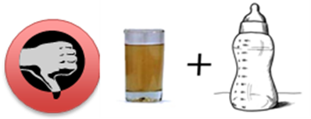
 | 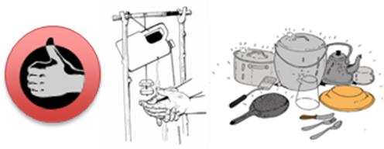

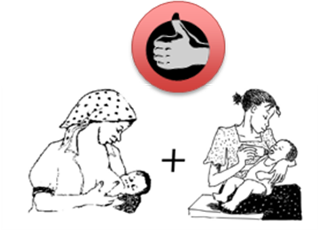 | Switching between breast milk and formula or animal milk CAN cause damage to the part of a baby that helps them digest food and may allow the HIV virus to pass more easily from an HIV-positive mother into her baby’s body. This increases the baby’s risk of getting HIV.

Putting on gloves or plastic sheeting on your hands while handling faeces CAN help reduce the risk of spreading HIV and the germs that cause diarrhoea.

HIV can only live/survive for a short period of time outside of the human body, depending on the quantity or amount of HIV present in the body fluid and the conditions the fluid is subjected to. Therefore, it is very difficult to spread HIV outside of the body.

Treating an HIV-positive client’s drinking water CAN decrease the chance that the client will get diarrhoea. | 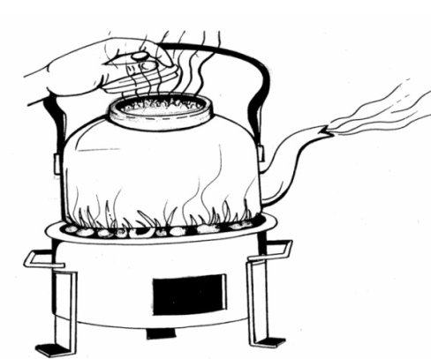

Handling your client’s HIV treatment medication without first washing your hands CAN cause the client to develop an opportunistic infection. | 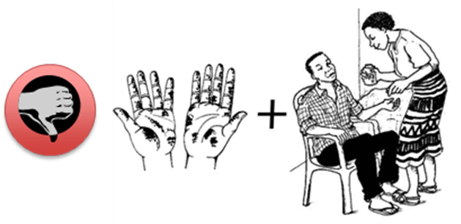

Soaking rags that are saturated with HIV-infected menstrual blood for at least 20 minutes in a mixture of “1 part Jik to 9 parts water”, then washing them with soap and water, and then rinsing and drying them in the sun WILL kill the HIV virus and adequately clean the rags so they can be reused. To throw out the soaking water, dig a hole and dump the water in. | 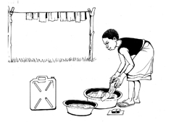

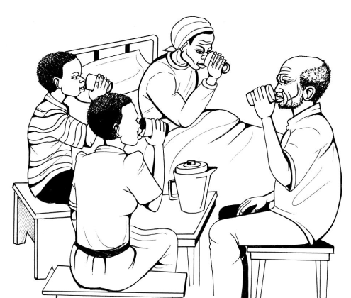 | HIV CANNOT be spread (to an HIV-negative person) by sharing treated water from a jerrican with an HIV-positive person.

HIV CANNOT be transmitted (to an HIV-negative person) by sharing a toilet/latrine with an HIV-positive person. | 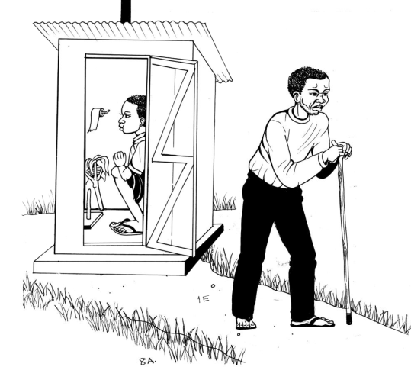

Remember that HIV is spread from one person to another person by sharing blood and body fluids from sexual intercourse, mother-to-child transmission during pregnancy, birth or breastfeeding, and through direct blood-to-blood contact.
It is your responsibility to protect
yourself and others by doing actions that
reduce the chance of spreading HIV
You not only have the responsibility to protect yourself from HIV, but also to tell others how to avoid HIV infection. You can do this by:
- Educating on safer sex practises such as promotion of abstinence, reducing the number of sexual partners and using condoms.
- Helping HIV-positive women get the health services they need to prevent the spread of HIV to their unborn or newborn child, including help to not mix other foods or fluids with breastfeeding.

- Making sure that only blood that has been tested for HIV (“safe blood”), is used for transfusion.
- Doing simple infection control procedures called universal precautions, which include (but are not limited to) the following:
- Protecting your hands and any surfaces of the skin if/when they come in contact with anybody else’s blood or body fluids. Washing your hands with soap (or ash) before putting on gloves and after taking off gloves and disposing of them.
- If any skin needs to be pierced or cut, making sure the needles, knives, syringes or other instruments are sterile (germ-free and disinfected after every use). Make sure these instruments are safely handled, never shared after they are used and disposed of in safe location.

Universal Precautions are described in further detail in unit 4, section 19 (page 54).
Unit 2: Hand Washing

4. Why You Should Wash Your Hands
Hands are always dirty with germs. We transmit germs from one person to another with our hands. Hands come in contact with many germs throughout the day, including when cleaning ourselves after we defecate. No matter what material (toilet paper, newspaper, leaves, etc.) is used to clean yourself after defecating, your hands still get dirty from the faeces (even if you cannot see or smell what got on your hands). For this reason, both hands should always be washed using soap (or ash) after defecation or after using a latrine.
One very important way illnesses are spread from one person to another person is through people’s hands. Research studies show that washing your hands can reduce the risk of getting sick with diarrhoea by as much as 45% and also suggest that unwashed hands contribute to the spread of respiratory illnesses.

5. How to Wash Your Hands with Soap (or Ash)
STEP  1 | Wet both of your hands with water. It does not matter if the water you use is in a bowl or whether it is running water. It is important to use running water only when rinsing your hands.
STEP  2 | Lather with soap (Note: if no soap is available, it can be replaced with ash, another cleansing agent).
STEP  3 | Rub your hands together thoroughly. It is the soap (or ash) combined with the scrubbing action that helps loosen and remove germs.
STEP  4 | Rinse your hands with running water Rinse with water poured from a water container such as a Jerrican, pitcher, cup, jug or tap to sweep away the loosened germs.
STEP  5 | Shake the excess water off your hands and allow them to air dry.

6. What You Need to Wash Your Hands

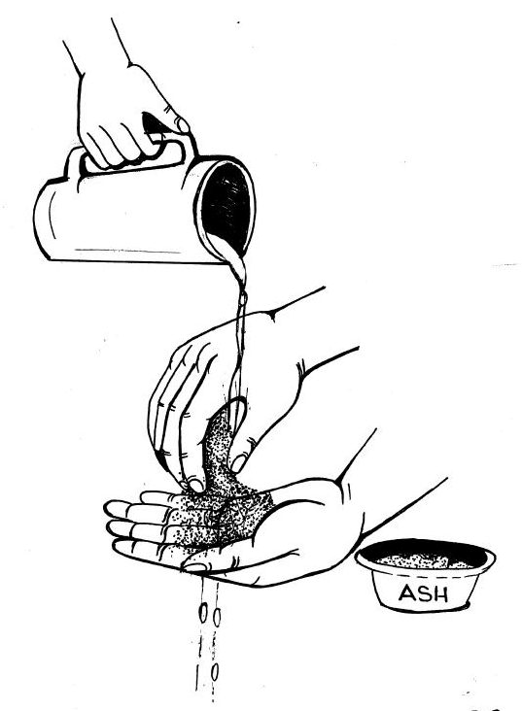 | 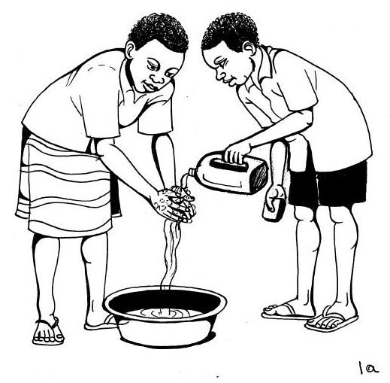
You should wash your hands with water and soap. If you don’t have soap, you can use ash instead. It serves the same purpose as the soap, to help ‘scrub’ what is stuck on your hands, so the running water can sweep it off. You can wash your hands with water that has not been treated, and still get clean hands, as long as you POUR the water over your hands (no dipping in a bowl!). The soap or ash “lifts” the dirt, and the water then washes off the visible and invisible germs.

7. When You Wash Your Hands
There are many important times you should wash your hands; however, in your role as a HBC provider you, your clients and their family members should wash hands at the following “critical times:”

BEFORE:  - Preparing food and cooking  - Eating or feeding someone  - Taking or giving medications  - Putting on gloves/plastic material, cleaning wounds, or handling any blood or body fluids | AFTER:  - Defecating (passing faeces)  - Cleaning your own or your client’s private parts (e.g., cleansing due to urination, defecation, menstruation).  - Changing a nappie/diaper and cleaning a baby’s bottom  - Taking off gloves/plastic materials, cleaning wounds, or handling any blood or body fluids
8. Who Should Wash Their Hands?
Everyone should wash their hands including adults, the elderly, young people, children and babies. If children are unable to wash their hands by themselves, an adult should help them.

9. Hand Washing Station
A hand washing station is a place that has all the supplies that you need for washing your hands. Having a hand washing station increases the chance that people will actually wash their hands. It is especially important to set up a hand washing station by your latrine and/or near where food is prepared and eaten.
A hand washing station should include:
- Soap (or ash) to lift the germs off your hands
- Water to wet your hands
- Water in a container (such as a jerrican, saucepan, pot, bucket, cup, basin, etc.) that easily allows you to pour water over your soapy (or ash covered) hands.
- A vessel or container to hold the used water that is then thrown out.

10. Tippy-Taps for Hand Washing

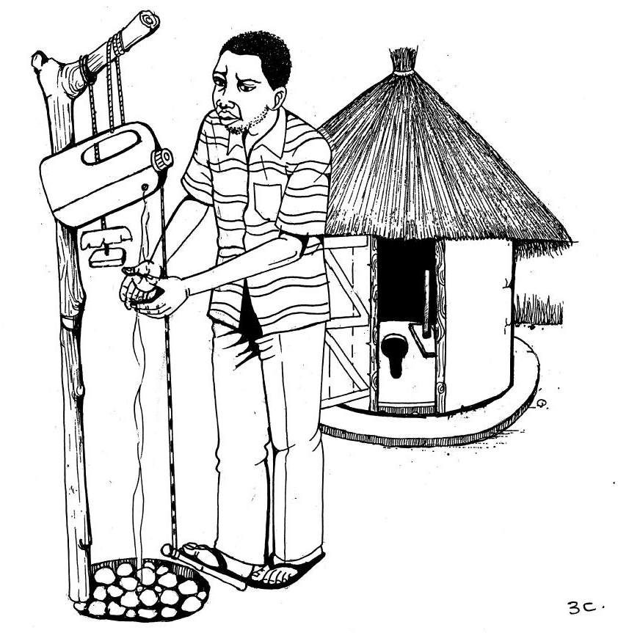
A “Tippy Tap” is a device that helps you wash your hands using very little water and can be part of a hand washing station. It consists of a container filled with water (such as a 3- or 5-litre jerrican) that has a small hole made in it to allow a very small stream of water to pour out to wet and rinse your hands. For some tippy tap models, one end of a rope is attached to the container and the other end of the rope is attached to a stick on the ground. When the user steps on the stick it tilts the container so that the water spills out.

A piece of soap (or a container of ash) should be attached to the pole/stick that supports the tippy tap. When you correctly use a Tippy Tap that has a foot lever attached, only the soap or ash is touched during hand washing, making it an effective way to wash your hands without contaminating them in the process.

How to build a tippy tap
Follow these easy steps build your own Tippy Tap:
STEP  1 | Marking the hole:  Select a clean, empty 3-litre or 5-litre plastic container for your Tippy Tap. Mark the location for the hole on the container, around 12 cm below the cap.
STEP  2 | Heating the nail:  Hold the nail with a pair of pliers or a cloth, and heat the nail with any flame, such as from a fire, a candle or a lighter.
STEP  3 | Making the holes:  With the hot nail, make the hole in the container, and a second hole in the cap.
STEP  4 | Inserting the rope:  Put the longer piece of rope (1-metre) through the hole in the cap. Start by putting the end of the rope through the outside surface of the cap so that the loose end of the rope ends up on the inside of the cap.
STEP  5 | Knotting the rope:  Make a knot in the rope that rests on the inside surface of the cap. Make sure the knot is big enough that the knot cannot be pulled back through the cap. Screw the cap back on the container. The knot should now be inside the container with the remaining long, loose end of the rope hanging outside the container.
STEP  6 | Attaching the stick (foot pedal):  Tie the end of the rope to a 1-metre stick. The stick is now connected to the container with the rope. This is the foot pedal of the Tippy Tap.  Note: You can adjust the length of the rope, if needed, during Step 11.
STEP  7 | Making the hole through the soap:  Using a tool (e.g. screwdriver, thick stick), make a hole through the soap by slowly rotating and pushing the tool through the soap.
STEP  8 | Inserting the rope:  Put the shorter, second piece of rope (.5 metre) through the hole in the soap and tie to a short stick or piece of wood.
STEP  9 | Filling the container:  Fill the container with water, up to the level of the hole.
STEP  10 | Putting the poles in the ground:  Decide the best place to put you’re your Tippy Tap. It should be where frequent hand washing should take place, such as near a latrine or kitchen. Using a tool to dig holes (e.g. shovel, spade), make two holes in the ground to a depth of 50 cm. Place the poles about 70 cm apart. Put the poles in the holes and pack the soil around them.
STEP  11 | Hanging the Jerrican, the foot pedal stick and the soap rope:  - Put the stick through the handle of the Jerrican, and put the stick between the two poles. The Jerrican should now be hanging from the stick.  - Tie the rope with the soap near the Jerrican so it is hanging from the stick. (If no soap is available, a container to hold ash can be used instead.)  - Make sure the rope for your foot pedal is adjusted so that one end of the stick/foot pedal hangs about 15cm above the ground and the other end of the stick rests on the ground.
STEP  12 | Make a soak pit:  Make a hole under the Jerrican where the water will likely fall (about 40x40cm in length and width and 20cm deep). Fill in the hole with rocks. This is a soak pit, which keeps the Tippy Tap from becoming a mud hole and a mosquito-breeding place.

To Use Your Tippy Tap:
- Push the stick down with your foot. This tips the container, which makes water run out of the hole. Wet your hands and release the stick. Apply soap (or ash) to your hands. Push the stick down again and rinse your hands.

To Maintain Your Tippy Tap:
- Keep the tippy tap full of water by refilling it regularly so it is lways ready for use.
- Wash the inside and outside of the tippy tap weekly or sooner if it looks dirty.
- Replace the soap (or ash) when it is gone.
- Unclog the soak pit of any soil clumps to prevent overflowing
- Replace the wooden sticks over time to prevent collapsing of the Tippy tap.

ANNEX 1:

ACRONYMS AND GLOSSARY

ACRONYMS

(An acronym is a word that is formed from parts of several words)

AIDS: Acquired Immunodeficiency Syndrome
ART: Antiretroviral Therapy
ARV: Antiretroviral
HBC: Home Based Care
HIV: Human Immunodeficiency Virus
OI: Opportunistic Infection
ORS: Oral Rehydration Salts
PMTCT: Prevention of Mother-to-Child Transmission (of HIV/AIDS)
TB: Tuberculosis
WASH: Water, Sanitation and/or Hygiene

GLOSSARY

(Words and their meanings in alphabetical order)

- A -
Acquired Immunodeficiency Syndrome (AIDS): the name given to a group of illnesses in HIV positive people. These are illnesses that arise when people living with HIV are no longer able to fight off infections because of lowered immunity.
Active Listening: a counselling skill that involves paying close attention to what a client is telling you and showing the client that you are paying attention.
Adequate: enough, what is needed without being too much.
Adherence: to be conscientious in following something, in this case in taking medicate according to the doctor’s prescription
Adolescent: young people who are no longer children, and are starting to become adults
Advocate: to speak out for a desired goal and strive to achieve it
Alternative: one or more things you can choose from, another options.
Anti Retroviral (ARV): drugs used to reduce the amount of HIV in a person’s body
Anti Retroviral Therapy (ART): a term used to describe giving ARV drugs in the correct way, with adherence support
Assumptions: supposing things without proof
Asymptomatic: not having any symptoms, even though infected with a disease.

- B -
Bacteria: tiny germs that can only be seen with a microscope; some are helpful to body function, but many cause different diseases
Bedbound Client: client that is unable or unwilling to leave the bed.
Bedpan/Plastic Basin: device to place under bedridden client to collect faeces/urine.
Bedsores: wounds on skin that result from lying in one position for too long. Also called pressure sores, bedsores result from constant pressure on a particular part of the body.
Bottle feeding: feeding from a bottle (content can be: expressed breast milk, water, infant formula, or another formula or liquid)

- C -
Case study: looking carefully at a set of circumstances for the purpose of learning
CD4: a common name for a type of white blood cell that fights infection that is destroyed by HIV. The more CD4 cells a person has, the healthier he or she is.
Checking Question: questions which allow counsellors to finds out how much a client has understood and what topics need further information or explanation
Chlorinating: adding chlorine to water
Chronic: long-term or frequently recurring (compare with acute). A chronic disease is one that lasts a long time that cannot be cured. A chronically-ill client has a disease which is of long duration, without cure, but can be controlled- such as HIV, high blood pressure, diabetes, etc.
Classified: explained or organized in a certain way or order
Client: person receiving care from someone else (same as a “patient” although “client” is a more appropriate term)
Clinical: related to the science and practice of medicine
Closed Question: a type of question which requires a one-word, often ‘yes’ or ‘no’ answers only
Cohesiveness: sticking together
Colleague: a fellow worker
Community: a group of people living in the same village or area who have similar living conditions, interests, and problems
Compassion: feeling for the suffering of others
Complications: secondary health problems that sometimes develop in the course of a disease. For example, meningitis may result as a dangerous complication of measles
Comprehensive: including everything.
Concept: an idea
Condom: a thin, protective sheath that fits over the penis during vaginal, anal, or oral sex to prevent sexually transmitted disease or pregnancy. There are also female condoms that fit inside the vagina.
Confidentiality: the obligation owned by one person to another not to share information given by or about another or the obligation to share it only in limited circumstances. Or, to be entrusted with someone’s private information and the understanding that certain information and actions will be kept private
Consistent: stays the same
Constructive criticism: a helpful and practical review/assessment/critique of a particular situation.
Contact: touch. Contagious diseases can be spread by a sick person coming in contact with (touching or being close to) another person
Contagious: easily passed from one person to another. A contagious disease is an illness that can be spread easily from one person to another.
Contaminate/Contamination: to dirty, stain, or infect by contact. The process of introducing harmful substances, such as germs.
Consideration: something that is to be kept in mind when making a decision or evaluating facts
Conversation: an informal talk between two or more people, a discussion.
Counselling or counselling skills: techniques used by counsellors or trained people to communicate well with clients who may need help on a problem(s) and necessary to develop a good counsellor/client relationship.
Counselling Card: a piece of paper with pictures and words to help Home Based care providers talk more easily with their clients and other client and/or their caregivers in the home around a specific topic.
Critical times: when washing your hands is absolutely necessary, most important and the risk of spreading germs with your hands is high
Culture: the beliefs, practices or values of a group of people.
- D -
Decontamination: the process of removing or destroying harmful substances such as germs
Defecate: to pass faeces (waste product, poop, poo, shit or stool) from the colon to the rectum through the anus
Defecation: process of defecating or passing faeces (waste product, poop, poo, shit or stool) from the colon to the rectum through the anus
Dehydrated: a term used to describe the result of losing water from the body through sweating, fever, diarrhoea or vomiting. Dehydration is a condition in which the body loses more liquid that it takes in. This lack of water is especially dangerous in babies, elderly and people with compromised immune systems.
Describe: explaining what someone or something is like
Dexterity: use or control of physical and mental power
Diagnosis: a medical practitioner’s conclusion about what a sick person is actually suffering from
Diarrhoea: a condition in which watery stools are passed three or more times a day.
Differentiating: to make a change
Digest: the process the body uses to turn food into energy after a food is eaten
Dirt or Dirty: with visible soil, particles, rough ground, not clean
Discard: get rid of
Disclosure: the process a person goes through to tell others about their status (e.g. to disclose your HV status).
Discrimination: a term used to describe treating other people differently or unfairly because they are different from others in some way
Discuss: to talk between two or more people, a conversation or discussion.
Disinfect: clean something with a chemical that destroys germs
Dominant: stronger
Draw Sheet: a bed sheet, usually used with a waterproof pad, that is placed on the bed of an incontinent client to protect the other bedding or may be used to lift/ turn/position/or move a client.

- E -
Elicit: come to a conclusion by reason
Eliminated: taken away
Enabling: to make possible, able; give power, means, or ability to
Essential: needed, required
Empathy: a term used to describe trying to understand a situation from another person’s point of view and showing that you care.
Emphasize: make it clear that something is important.
Endorse: to give approval, sustain or support of something
Enhance: improve something, make it stronger, cleaner etc.
Equipment: the tools or machines that are used to create or do something
Esteem: respect and admiration for someone.
Eventually: in the end, after a long time.
Exclusively: only, nothing else.
Exclusive breastfeeding: when a mother ONLY breastfeeds her child (usually recommended for the first 6 months of life).

- F -
Facilitate: to assist in the progress
Facilitator: a person who makes it easier for a process to happen
Faeces: waste product from the colon, or poop, poo, shit or stool; the waste from the body that is moved out through the bowels when someone defecates or has a bowel movement
Faeces-to-Mouth or Faecel Oral: spread or transmitted from the faeces, poop, poo, shit or stool of one person to his or another person’s mouth, usually through food or drink, or on fingers
Filtering: using a cloth to pour water through in order to remove sand or dirt
Frail, elderly Client: older persons with poor or limited ability to function physiologically due to age and conditions of older age

- G -
Gender role: behaviours that pertain to males and females
General Hygiene: keeping the body and surroundings fresh and clean
Genitals: reproductive organs, especially external sex organs
Germ: a very small organism or infectious particle that can grow in the body and cause some infectious diseases
Granule: a very tiny grain, similar to a piece of sand

- H -
HBC Providers: a person (male or female) trained to provide physical, psychological, spiritual and social care within the home, for client and/or their caregivers in the home, often within their own community. They are often volunteers who help people with health, water, sanitation and hygiene practices, provides some simple treatments, and refers sick people to clinics/medical centres for other necessary treatment.
Healthy Clients: not lacking physical strength or vigour; in a state of good health or other terms to indicate people are well, up and about or are without symptoms of problems.
HIV Exposed (infant): a baby who was born to an HIV Positive mother, and MAY have HIV, but has not yet been tested for HIV
HIV-Infected: refers to people who are infected with HIV, whether or not they are aware of it
HIV Infection: the result of HIV transmission, where HIV is introduced into the body and starts to multiply and spread.
HIV Negative: showing no evidence of infection with HIV
HIV Positive: showing indications of infection with HIV
HIV Related Illnesses: illnesses that PLWHA contract as a result of lowered immunity.
HIV status unknown: people who either have not taken an HIV test or do not know the result of a test they have taken
HIV Transmission: the process of spreading or contracting HIV through one of the three modes of transmission (sexual contact, blood to blood transmission, mother-to-child transmission).
Holistic: dealing with or treating the whole of something or someone, not just some parts. Usually refers to the physical, psychological, spiritual and social aspects of a person or the care that is provided.
Home-based-care: services given at home and/or in the community by a HBC provider who is trained to provide physical, psychological, spiritual and social care for client and/or their caregivers in the home. They are often volunteers who receive no or a limited salary and some incentives to help households with health, nutrition, water, sanitation and hygiene practices, provides simple treatments, physical therapy, medication adherence and support, advise on sexual behaviours, and refers sick people to clinics/medical centres for other necessary treatment
Household Hygiene: keeping the surroundings, houses, compound, etc., clean
Household or household members: people living within the household, often family members (but not always).
Human Immunodeficiency Virus (HIV): the virus that causes AIDS by weakening the body’s immune system. “Human” means the disease attacks people, “immunocdeficiency” means it attacks the immune system, and “virus” refers to what causes the disease
Hurt: cause pain, injure someone
Hygiene: actions or practices of personal cleanliness that lead to good health (e.g. hand washing, bathing, etc)

- I -
Illustrate: give more information or examples
Immobile Clients: clients with mobility problems who are not able to move about.
Immune System: the body’s defence system, which recognizes and fights germs and infections
Implementing: a means of achieving an end
Inappropriate: not acceptable, not suitable
Incontinent Client: client with partial or complete loss of urine or faeces control.
Infant: a baby - from birth to 12 months of age
Infection: a sickness caused by germs. Infections may affect part of the body only or all of the body.
Infectious disease: a disease caused by a germ (bacteria, viruses, fungi, parasites).
Interpersonal communication or IPC: face-to-face interaction or communication between two or more people that is useful and effective
Interpret: explain or decide what you think about a particular issue
Interrupt: stop someone while they are talking or doing something by saying or doing something yourself
Intervention: actions taken to prevent something from happening, or to make something happen
Intestinal Parasites: worms and tiny animals that get in people’s intestines and cause disease

- J -
Jerrican: a plastic container used to hold water

- K -
Knowledge: information and understanding about something

- L -
Latex: a type of rubber used to make condoms, medical gloves, and other very thin, flexible materials
Latrine: an outdoor structure with a hole or pit in the ground which is used as a toilet
Leading Questions: a type of question in which a counsellor guides (or leads) the client to five an answer that her/she wants to hear
Lesions: abnormal tissue (sores) usually caused by disease - they are most commonly found on the skin or in the mouth.
Linen: sheets, blankets, pillowcases, quilts and other bedding
Litre: a unit to measure volume (liquid)

- M -
Malnourished: not having enough good, healthy food to eat. Malnutrition is a term used to describe a condition where the body does not either get enough of the right foods or it cannot process foods properly to remain healthy. It is a health problem caused by not eating enough of the foods that the body needs.
Mackintosh: a rubber sheet that is placed under the client’s hips to protect the bedding from being soiled
Menstrual Period, menstruation: monthly bleeding in women
Mixed Feeding: feeding a baby breast milk and other foods or liquids (example: water, formula, tea, dairy milk, etc. Mixed feeding increases the chance of transmission of HIV to infants.
Mobile Client: client that is able to move without help from another person
Mobilize: encourage and prepare to take action
Mode of transmission: the way a disease spreads from one person to another
Module: in this context, a specific part or section of a training curriculum.
Mother-To-Child Transmission (MTCT): when an HIV infected mother passes HIV to her baby through pregnancy, during childbirth, or after delivery through breastfeeding.
Mouth Care: ensuring the proper cleaning of the mouth (teeth and gums) to prevent infection and decay.

- N -
Nausea: stomach distress or upset; feeling like you need to vomit.
Neglect: fail to give someone the attention or care they need.
Negotiation (or negotiate): to discuss and come to mutual (or joint) agreement with another person which results in a different conclusion or effect.
Non-Adherence: not taking medications as they are prescribed
Nutrients: the substances we absorb from food that we need for growth, energy, to build our bodies and stay strong
Nutrition: food, feeding; providing a balanced diet. Nutritious foods are those that have the things the body needs to grow, be healthy, and fight off disease

- O -
Objectives: the object of a person’s action or goal
Opaque: not clear – difficult to see through
Open Question: a type of question that requires more that a one-word (yes or no) answer and encourages people to explore their situation or feelings
Opportunistic Conditions/Infections (OIs): infections and diseases that attack the body when the immune system is weak. They are common in clients whose immune systems are weakened by HIV
Oral: by mouth. An oral medication is one taken by mouth
Oral Rehydration Salt Solution: medicine given to people who have diarrhoea and/or vomiting to replace the lost water and salts. A drink used to help prevent or treat dehydration.
Organism: a living thing (animals or plants)

- P -
Paraphrasing: to restate what has been said in other words
Parasite: a plant or animal that lives on or in another plant or animal, usually hurting its "host"
Participant: group member or contributor
Peer Support: support for people by another person who is in the same situation or has the same disease
Penis: external male sex organ
Perceived: to recognize, discern, envision or understand
Perception: ability to notice something, the opinion someone has of something.
Perhaps: maybe, possibly
Perineal area: The region between the base of the penis and the anus in males, and between the vulva/vagina and the anus in females.
Persistent: carrying on, not giving up.
Personal Hygiene: in terms of food safety, involved ensuring that people who are touching and handling food take proper care to ensure that they do not pass on bacteria or viruses.
Petroleum Jelly (petrolatum, Vaseline): a grease like jelly used in preparing skin ointments which is petroleum (crude oil) based.
Physical: to do with the body or with things that can be seen and touched.
PLHA: people living with HIV/AIDS.
Plenty: a lot, more than enough.
Pneumonia: an infection of the lungs often producing cough, fever, and difficulty breathing. Note this is different from tuberculosis.
Point-of-Use: in terms of water treatment, this means treating water in the home (with chlorine for example), rather than at a water facility plant many kilometres away.
Positive Living: a term used to describe steps taken by people living with HIV or IADS that enhances their lives and increases their health.
Precautions: things that you do to prevent something bad from happening in the future.
Pregnancy: the time period (normally 9 months) when a woman carries a child inside her.
Prevalence: measure of how common or widespread a disease or infection is in the community or population at a given period of time. This measure includes existing and new cases.
Prevention: action taken to keep or stop germs or illness before they start.
Preventive Care: a term used to describe caring efforts intended to prevent discomfort in PLWHA. Examples include: mouth care, prevention of bed sores, proper bathing, prevention of pain and stiffness in muscles and joints and ensuring bedridden clients are comfortable.
Procedure: the specific way a thing is done.
Product: something you can buy that is man-made.
Prophylaxis: a therapy or treatment taken to prevent infections.
Psychological: relating to the mind or mental processes. Psychosocial support is caring for the emotional and psychological, well-being of others.

- Q -
Questioning: a communication skill that helps the provider understand the client’s situation. This skill can determine the quality of information a provider receives from the client.

- R -
Rapport: a relationship of mutual understanding or trust and agreement between people.
Rate: the number of times something happens in a given amount of time.
Recurrent: happens or occurs again and again.
Rectum: the end of the large intestine close to the anus.
Refer or a Referral: suggest that someone go somewhere or do something; when you refer a client, you encourage them to go and follow up with them to make sure they go. In this context, a referral usually means sending someone from the home or community to a health facility (hospital, health centre, dispensary) or from the health facility to the community.
Reference: a note that shows where something is discussed in more detail.
Participant’s Guide: a handbook of extra materials for people who attend the training.
Rehydrate or Rehydration drink: replace fluids/liquids and nutrients in the body. Consume a drink to correct dehydration, which you can make with ORS solution and treated water or with sugar and salt and treated water.
Reluctant: unwilling
Replacement feeding: feeding infants who are receiving no breast milk with a diet that provides the nutrients infants need until the age at which they can be fully fed on family foods. During the first 6 months of life, replacement feeding should be with a suitable breast milk substitute. After 6 months the suitable breast milk substitute should be complemented with other foods.
Replenish or Replenishment: Restock or refill (example: putting food or water in a hungry body)
Research: studying to discover the facts or get new information about something
Resistance: -the ability of something to defend itself against anything that would normally harm or kill it. Sometimes bacteria become resistant to the effects of certain antibiotics or HIV may become resistant to certain ARVs.
Respiration: breathing. The respiratory system includes the bronchi, lungs, and other organs
Respiration rate: the number of times a person breathes in one minute
Risk: the possibility of injury, loss, or harm. Danger
Role-play: a learning exercise where participants pretend or act out a part or character that may be different than themselves

- S -
Sachet: a small envelope with very small, loose dry grains
Saliva: spit. The fluid in the mouth
Sanitation: making clean
Scrotum: the bag between a man’s legs that holds his testicles or balls
Seldom: not often
Self-assessment: checking yourself and making your own comments about how much you know about a subject or how well you performed a task
Self-Care: thoughts and activities that people do to take care of themselves and improve their health
Self-Esteem: confidence in yourself and belief in your qualities and abilities
Self- Management: when a client takes responsibility for his or her own health care.
Semen: thick, white fluid containing sperm that a male ejaculates
Session: in this context, a specific part or section of a training module (unit).
Settling and Decanting: the process of letting cleaning water by letting the “dirt” go to the bottom of the container and pouring out the clear water
Sexually Transmitted Infections (STIs): infections that is passed from one person to another through sexual activity
Side Effect: a bad reaction to a drug or other form of medical treatment
Signs: the things or conditions one looks for when examining a sick person, to find out what sickness he/she has
Significant: important, meaningful
Shrink: to become smaller
Simultaneous: happening at the same time
Soiled Linen: bedding that may have a substance on it such as faeces, urine, pus, blood, etc.
Solution (liquid): a liquid used to treat water
Spigot: tap, spout or other control device
Spread: increase or multiply
Sputum: a substance coughed up from the lungs
Sterile: completely clean, new and free from micro-organisms. Things are usually sterile by boiling or heating or purchasing a new, sterile product which has been sterilized
Sterilize: to kill microscopic organisms in something so that they cannot cause infection
Stigma: negative attitudes toward people who belong to a particular group or who have different characteristics than others. Usually attached to something that the community believes is socially unacceptable
Stomach: the sac-like organ in the belly where food is digested
Straight: without going from side to side, in a clear way, immediately
Substance: the material, stuff or the central part of a situation
Sufficient: enough
Supplement: an extra or added amount to something
Supply: to provide; or an amount of something
Summarizing: stating what has been said
Sustainability: to keep up or keep going
Symptoms: any aches, pains, conditions, feelings or other problems a person describes or reports to another person

- T -
Tablets: small pills
Teaspoon: a measuring spoon that holds 5 millilitres (ml). Three teaspoons equal 1 tablespoon
Terminally Ill Clients: with disease which is life-threatening or final, fatal illness which cannot be controlled or cured.
Tippy Tap: a simple, hygienic device for hand washing with running water. A 5 litre container with a small hole near the cap is filled with water and tipped with a stick and rope tied trough a hole in the cap.
Tool: an instrument or a method (way of doing something) that helps improve the process and/or end result.
Traditional: something that has existed for a long time without changing
Transfusion: the process of transferring blood from one person into the circulatory system of another
Transmit: to spread or pass along; how an infected person gives a disease to someone else
Tuberculosis (TB): a contagious disease caused by a germ that is breathed into the lungs. It is a common opportunistic infection among PLWHAs
Tumpeco or Nice cups: a plastic cup commonly available in Uganda, which is the size of a half-litre or 500ml
Turbid: cloudy or dirty (usually referring to water)

- U -
Universal Precautions: simple infection control procedures that reduce the risk of spreading germs and illness through exposure to blood, body fluids, or contaminated equipment, surfaces, or materials.
Urinal: a container or jar for urine, especially for use by people who cannot get out of bed
Urine: liquid waste from the body; piss; pee
Utensils: tools you use for doing jobs in the house, especially cooking
Utilize: make useful

- V -
Vagina: the tube or canal structure that leads from the opening of women’s sex organs to the entrance of her uterus or womb
Vaginal Secretions: fluids that come from a woman’s vagina; they help make sex smoother and protect the vagina from injury and infections
Viral Load: a term used to describe the amount of HIV in a person’s body. The more HIV, the higher a person’s viral load will be.
Virus: a germ smaller than bacteria, which causes infections and is easily spread from one person to another
Vulnerable: not well protected; weak or open to harm

- W -
Weak Client: lacking physical strength or vigour; infirm, esp. as compared what would be the normal or usual for that individual.

- X -
Young Child: a child aged from 1 to 4 years.

- Numbers -
1:9 Jik solution: a specific ratio of bleach to water mixture – one part Jik to nine parts water.

ANNEX 2:

TOOLS TO IMPROVE WASH PRACTICES
Part of your job as a HBC provider is to help your clients and their caregivers in the home:
- Assess and become aware of what practises they currently are or are not doing
- Identify which practises they are currently doing that might be bad for their health or their family’s health
- Choose what practises, if any, they want to improve
- Identify barriers or the things that make it difficult to improve those practises and how to overcome those obstacles.

The commitment by clients and their caregivers in the home to change their practises is guided by many people (including yourself), but the final decision on what to change and how to change it should be made by the client and/or their caregivers in the home.

Assisting and guiding clients and their caregivers in the home to change their routine practises (or behaviours) is often not an easy task for a HBC provider to do. It requires knowledge, practise, skills, and ongoing support from other providers and supervisors. This tools section is designed to help the HBC provider develop the knowledge and skills they need so they can talk with their clients and their caregivers in the home and to improve the way in which they usually treat, transport, store and serve their drinking water; handle and dispose of faeces and menstrual blood; and wash their hands. It introduces five sets of tools that can provide you guidance when working with your clients and their caregivers in the home:

TOOL  1 | Interpersonal Communication Skills – Using skills to talk with your client and their household effectively.
TOOL  2 | The 4 A’s Steps - Learning and using a series of steps or method of talking with the client and coming to a mutual agreement on improving practise(s).
TOOL  3 | WASH Assessment Tool- Using steps and an Assessment Tool to help you assess current WASH practises in the household.
TOOL  4 | WASH Counselling Cards – Using a set of cards with pictures to help you talk with the client and/or the client’s caregivers in the home about how improve their practises in the household.
TOOL  5 | Supplies to Help You Improve WASH in Home Based Care – suggestions on essential equipment

Tool 1:
Interpersonal Communication Skills

To help someone change their practises (or they way they customarily do things), it is important to have good “interpersonal communication”, which is direct, face-to face conversation between two or more people to exchange experiences and share ideas, beliefs, fears and doubts about a specific topic. It involves two types of communication channels:
- Verbal communication (when we use spoken language)
- Non-verbal (when we use gestures, mime, signals, etc.)

Providers must actively listen to the client and see their situation through the client’s point of view to be able to adapt messages to the specific situation of their household and come to a mutual decision with the client on how they can improve or change a practise. Being sensitive to the client’s culture, religion and traditions is also essential, as well as building rapport, or making the clients feel welcome and at ease.
Signs that you are or are not listening actively to you client include:
Signs That You ARE Listening | Signs That You ARE NOT Listening
Facing the client | Looking away or around the room
Looking at the client when he or she speaks | Being distracted
Nodding | Not acknowledging what is being said
Smiling or frowning appropriately | Moving around too much or fidgeting
Being calm | Writing notes, finding papers
Being patient | Interrupting
Maintaining eye contact (if culturally appropriate) | Not allowing silent pauses in the conversation
Asking questions at appropriate intervals | Not directly answering or addressing the issue that the client has just raised because you are not listening
Using good body language – see below | Not listening actively or intently

Types of Questions and When To Use Them

Open ended questions
Open ended question is a question which gives the person an opportunity to volunteer information, experience, tell her/his story.
Open ended questions open up the discussion and should be used as much as possible.

Examples of open ended questions
- How do you store water?
- When do you make up the baby food?
- Why do you wash the bedclothes?

Open ended question should be used when we want to:
- Find out some information;
- Let the person explain things in her/his own words;
- Open up the conversation;
- Allow the person to talk more fully about their situation;
- Help get the person talking if s/he is shy to talk

Closed questions
A closed question is a question which either leads to single word answers or “Yes” or “No” answers.
Closed questions do not open up the conversation and the HBC worker may then have to ask another question. These types of questions are very useful to gather specific information and predict a brief answer e.g. when you need to keep someone who talks a lot on track.

Examples of closed questions:
- Do you have access to water?
- How many times a day do you wash your hands?
- Is there a latrine in the compound?

Checking questions
A checking question can help you to find out how much the person has understood or if you have understood, and help you decide if you need to give further information or better explanation.
Checking questions can be used for checking you have understood the person you are working with, and for checking that the person has understood you. A checking question can do two things. It can help you to find out how much the person has understood and it can help you find out what needs further information or explanation.

Examples of checking questions:
- What changes have we agreed to make today in the way you use your water supply?
- How are you going to use the soap and water from now on?
- What I have heard is that you would like to build a latrine and you think both your husband and landlord would object?

Leading questions
Facilitator builds on participants’ answers and state: A leading question is designed (either intentionally or subconsciously) to lead the person to a particular answer.
Leading questions are based on the questioner’s assumption/s. These types of questions do not help the person questioned to be open about their true feelings or actions.

Examples of leading questions:
- You understand about how germs can cause infection now, don’t you?
- Now that we’ve talked, you can store your water safely, can’t you?
- You don’t have any more questions about hand washing, do you?
- You know better than me to store your water in an open container, right?

Why? Questions
Questions that ask why something is being done, has happened etc.
“Why” questions can sometimes be useful, but should be used carefully - with a gentle tone of voice and some qualification (words that soften the effect of the question) - otherwise these types of questions can sound accusing and can feel threatening and judgmental. Often it is better to turn this question into a statement that allows the person to explain their behaviour without feeling threatened or judged.

Examples of why questions:
- I’m interested in why your village has this particular way of treating diarrhoea in children - can you explain it to me?
- I’d like to understand why you feel that women shouldn’t use the latrine in the daytime.
- Can you tell me more about why your family can’t wash their hands with soap and water every time they use the latrine?

Asking 2 Questions at Once
There is a common trap that can catch us if we do not carefully watch and plan what we are asking, that is, asking two questions together. We often ask two questions together in ordinary conversation.

Examples of 2 questions at once:
- How did you manage with teaching your family hand washing? Did it go fine?
- What did he say about cleaning the latrine? Did he make a plan with the village?
- How do you know the water is clean? Do you boil it, or use a water purifier?
- What was discussed at the village meeting? Did everyone agree that a village hygiene committee needs to be formed?

Note how in these common ways of asking questions, the first question is open while the second question is a closed or a leading question. This helps the person asking the question to “limit” the response of the person being asked (the person asking the question probably isn’t even aware that this is what s/he is doing – we all do it so often in ordinary life, and it is useful for us as human beings – it would be impossible for us all to talk in open questions all the time). But we need to be very careful NOT to ask two questions together – it won’t help us get the answers we really need and the client won’t have the opportunity to say what s/he really thinks.

Good Body Language
- Being relaxed, not appearing embarrassed, awkward, or shocked — even if the listener might be feeling some of those things;
- Having an open posture, e.g., arms in a comfortable position and at one’s sides, not folded across chest;
- Leaning forward, and moving, shifting positions in response to the way the client is sitting. (In good listening, the listener does this without even noticing — she/he mirrors the way the client sits and moves — this is a good indication that communication is good);
- Eye contact, as appropriate to culture and gender, but not staring;
- Sitting posture:
  - Sit sideways at a 45 degree angle to the person (sitting fully facing the person can be intimidating, especially if the person is feeling embarrassed about the conversation — sitting sideways, at an angle of 45 degrees gives the person an opportunity to look elsewhere if he/she needs to at times);
  - Sitting at the same or lower level (if the same level is not possible) — if the provider sits higher than the client, it unconsciously suggests the provider is more important;
  - Sitting without barriers (e.g., a clinic desk - between the client and the provider, although sitting at a kitchen table with the client (at a 45 degree angle) would be a comfortable and normal way of sitting in someone’s home.

Tool 2:
The Four “A” Steps
Home Based Care providers are continuously assisting clients and caregivers in the home with their needs and helping them take on healthier practises. Experience has shown that HBC providers can provide better care if they use a systematic series of steps which structures their work and the way they go about assisting a household with their needs. This is particularly important as providers need to remember multiple steps to observe, ask, think, discuss, plan and help households improve the way they wash their hands; treat, transport, store and serve their drinking water; and handle and dispose of faeces and menstrual blood. The “4 A’s” is the name of the series of steps that HBC providers can use to help them structure their interaction with clients and/or caregivers in the home.

They include the 4 steps of ASSESS, AGREE, ASSIST and ARRANGE.

THE 4 “A’S”
STEP: | GOAL: | TOOL:
1. ASSESS | - Identify current practices  - Congratulate on “good” practices  - Discuss practices that need to be improved | Assessment Tool
2. AGREE | - Mutually agree on ONE practice to improve (water treatment and/or handling, hand washing, faeces management, or menstrual period/cloth management)  - If ideal behaviour is not possible, mutually agree on appropriate small doable action(s) to implement | Assessment Tool  Counselling Cards
3. ASSIST | - Demonstrate new practise, if appropriate  - Identify potential problems/barriers and how to solve them  - Develop a “plan of action”  - Guide client where they can get help or materials needed within community

4. ARRANGE follow up support | - Set date and time for next visit  - Write down in your notebook current WASH practises and new, improved WASH practises client/caregiver will implement | Notebook or record keeping instrument

Key elements of each of the steps are outlined below:

1. ASSESS what is currently happening in the household around hand washing, water treatment and faeces/menstrual period management. In other words, check out, find out, question, or look into the water, sanitation and hygiene situation of the household. This includes:
- Collecting specific information by asking, listening and observing;
- Making a decision together about whether the client and/or household member is doing a WASH practise correctly or incorrectly based on your training in this course; and
- Exploring with the client and/or household member which practise(s) need(s) to be improved or changed.

2. AGREE: Discuss and come to a mutual agreement with the client or household member on what change is going to occur. Mutually come to a decision based on what is realistic and feasible for the household. This includes:
- Reviewing options for changing a WASH practise in your dialogue with the client and/or family member.
- Asking the client and/or family member to indicate their highest priority for what practise they feel they could change.
- Encouraging them to make even a small change that could benefit the household, even if it is not the “ideal practise.” At least, a small step can still bring about a benefit.
- Repeating in your own words the new practise that the client or family member wants to adopt to make sure that you and the client or family member are clear on the selected practise.

3. ASSIST or help clients and family members overcome barriers so they can make and sustain the changed WASH practise. Explain to participants that in order for a change in practise to become a reality, it is important to assist a client and/or family member in the following ways:
- Encouraging the client and/or family member in identifying what problems may occur exist when beginning to change the practise.
- Identifying who in the household may be able to help them with the new practise, what household items they need to support the practise, how to get needed items and demonstrating practises that may seem difficult to households.
- Repeat the plan of action with the client or household member in your own words to make sure you understand it clearly. Be sure to state what new “improved” practise will be implemented and how he/she/they will overcome any obstacles while improving the practise.
- If appropriate, guide the client regarding there in their community they can get help or supplies to help them implement their new practice.

4. ARRANGE follow-up support to the client and/or household member and document the changes or decisions to make changes in the household.
- Return to the household on a regular basis to encourage the client or household member to achieve his/her goal, especially when the client begins to put a new behaviour into practise.
- Document (write down) in your notebook or record keeping instrument the current WASH practise(s) and the new, improved practise(s) that will be adopted by the client and/or household member.

During a future visit, evaluate progress made by the client and/or household member in adopting the change. This can be assisted by Tool #3, the WASH Assessment Tool.

Tool 3:
How to Use the WASH Assessment Tool

Overview
Looking carefully at the water, sanitation and hygiene (WASH) needs of your clients and their caregivers in the home is a very important aspect of your role as a HBC provider. As you learned in the “4 A’s steps,” the first thing you do when you want to help a client or their household with their WASH needs is to first ASSESS, or check out, find out, question, or look carefully at the WASH practises of the client and other household members.

To help you do this task, a pictorially based WASH Assessment Tool was produced to help you ASSESS (the 1st of the 4 A’s) a household’s current practises in hand washing; treatment of drinking water; faeces disposal; and cleaning of rags used for menstrual blood (that will be reused). Assessing these practises includes your collecting specific information by asking, listening and observing and making a decision about whether the client or family member is doing a WASH practise correctly or not correctly. Using the WASH Assessment Tool, you, your clients and/or their caregivers in the home can identify the following important information:

Handwashing
1. If they wash their hands
2. What substance they use to scrub the germs off the hands (soap or ash)
3. How they rinse their hands during hand washing
4. If there is a need to be choosing a new and improved practice for hand washing (which will be discussed further in the next step, AGREE)

Safe Drinking Water
1. If they treat their water
2. How they treat their water
3. If there is a need to be choosing a new and improved practice for safe drinking water (which will be discussed further in the next step, AGREE)

Safe Handling and Disposal of Faeces (animal and human)
1. If they dispose of faeces or leave it out in the open
2. Where they dispose of their faeces
3. If there is a need to be choosing a new and improved practice for faeces disposal (which will be discussed further in the next step, AGREE)

Menstrual Cloth Cleaning for Re-Use
1. If they clean cloth that is used for soaking up menstrual blood
2. What they use to wash the cloth
3. If they use bleach to soak the cloth
4. If they dry the cloth in sunshine.
5. If there is a need to be choosing a new and improved practice for handling and cleaning menstrual cloth (which will be discussed further in the next step, AGREE)

How to Use the WASH Assessment Tool for the First Time With A Client or Household Member

How to Use the Assessment Tool
- Explain to the client and/or the client’s caregiver in the home that you want to talk with them about WASH practises you are trained in and how they do some things in the household.

- Ask the 4 questions on the Assessment Tool
Ask the client or the client’s caregiver in the home the 4 questions written on the Assessment Tool to understand how they are currently doing each practise. It is important to ask these questions BEFORE showing the client the tool.

- Show the WASH Assessment Tool to the client and/or their caregivers in the home and tell them that you are now going to review the Tool together line-by-line.
- Review the Assessment Tool Line-by-Line. For each line of the Tool, you want to identify current practises on each of the lines on the tool. You should do this by:
- Look at the Assessment Tool with the client or the client’s caregiver in the home
- Read the text beneath each picture out loud so that you are sure that the client/caregiver is clear on what the picture is meant to represent.
- Ask the client/care giver to point to the picture that is most similar to what they do in the home. (If the client/caregiver is having trouble figuring out which picture to choose, then you can suggest to them which choice might be appropriate according to the description they gave you in step 2, above.)
- Repeat this process for each line of the Assessment Tool.

- Discuss which current practices are “good/ideal” and which need to be improved.

Once all of the Assessment Tool is reviewed the HBC provider points out to the client/household member which practices they are doing that provide better protection against illnesses such as diarrhoea. These are the practices on the RIGHT side of the Assessment Tool. Congratulate the person on the practices they are doing well because it shows that you have noticed and are acknowledging that they have done some things well and will make them more receptive to suggestions for improvement. It is extremely important to let the person know what is well done and explain that the practice should be maintained.
Explain to participants that if a client and/or household member showed they currently do a practise(s) toward the left hand side of the Assessment Tool, then these are practises that are putting their health at risk and they need to start doing something that takes them closer to the right hand side because the practises on the right hand side provide better protection against illnesses such as diarrhoea. (For example, if a client shows the HBC provider that they do not treat their water then they need to start treating their water.)
- Choose ONE practise to improve.
Discuss with the client and/or caregiver which of the four topics (either hand washing, water treatment, faeces disposal or menstrual blood management) they would like to improve before you return for the next home visit. Remember that they should choose one practise for which they are not currently doing the “ideal behaviour.”
- Let the client and/or household member know that it is hard to change many things at once and that they are likely to be much more successful if they focus on one topic at a time. If they want to choose more than one, ask them “what you feel is most important topic for you to work on” and begin with the one they choose.

- Review Counselling Cards and Identify Small Doable Actions.
- Discuss the selected topic with the family member and decide if they are going to be able to achieve the “ideal” practice represented on the right hand side of the Assessment Tool. If they cannot achieve the “ideal practise,” then discuss some of the “small doable steps” that the family may be able to achieve (and which still bring about some health gains). These small doable steps are found on the Assessment Tool (as you move from left to right) and on the counselling cards, so it is useful to review the counselling cards for the topic that your client selected.

- Once the family has identified the practices they want to improve, repeat back to the client/household member what the improved practice is to make sure that both of you are clear on the selected practise.

Assessment tool “ideal practises” achieved:
If a client is already doing the “ideal practises” for all the categories on the assessment tool, then move on to using the Counselling Cards (in Tool #4) to help them identify other behaviours they might improve.

Client/caregiver does not want to improve their behaviour:
If the client or caregiver does not want to try a new practise, ask them to tell you about their desire to not change anything. Encourage them to make even a small change that could benefit the household (e.g. reduce diarrhoea; reduce money spent on diarrhoea medicines, keep children or grandchildren healthy, etc).
Ask them once again if they are willing to improve one of the items on the Assessment Tool and emphasise that it does not need to be the “ideal practise,” but rather, at least, a small step which can still bring about a benefit. If they continue to insist that they do not want to change anything (even though you explain again why it is important to make a change and have given them options for “small” and “big” changes), then it is possible that they are not ready to make any changes and that you cannot motivate them at this time. However, if they change their minds and decide that they want to make a change, congratulate them on wanting to improve the situation.

How to Use the WASH Assessment Tool During Repeat Home Visits with a Client

During follow-up home visits, information will be gathered on the client and the client’s household member’s progress regarding water, sanitation and/or hygiene improvements.
- Review with the client/household member the progress they made in accomplishing the new practise they elected during your previous visit.
- New practise is SUCCESSFUL: If the new practise is now being used correctly (was “successfully” implemented), congratulate them and determine what additional new practise they would like to improve. You can determine the additional new practise by looking at your notes from the first time you used the Assessment Tool with the client/family to refresh your memory about where they needed to improve. (Or: you can repeat the step of using the Assessment Tool to determine what practises need to be improved.) Discuss the practises that need improvement with the client and/or their caregivers in the home and agree on a new “improved” practise they want to try.

- New practise is UNSUCCESSFUL: If the new practise they chose during your previous visit was not adopted (they were not “successful” with the new practise), discuss what the problems were and try to help the family figure out how to overcome them. With the client and/or their caregivers in the home, brainstorm ways to overcome the problems they had. This will help the family decide if they want to continue trying the practise they chose during your previous visit (which was unsuccessful) or if they want to choose a different, “improved” practise to try. If they cannot overcome the problems they had, then help them choose a completely different practise.

Tool 4:
How to Use the WASH Counselling Cards

Overview
The WASH Counselling Cards are designed for HBC providers to help them talk with their clients and households. Using this WASH Counselling Cards as a guide, the HBC provider can show the client and/or their caregivers in the home illustrations of important water, sanitation and hygiene practises and can better explain how those practises can be improved. HBC providers can use these cards to help clients and their caregivers in the home:
- Make informed choices for improving the way they wash their hands; treat, transport, store and serve their drinking water; and handle and dispose of faeces and menstrual blood;
- Identify and use locally available supplies and materials to meet their needs; and
- Understand and adopt practises that promote improved hand washing, safe drinking water, and safe handling and disposal of faeces and menstrual blood.

When to Use the Counselling Cards

There are 23 WASH Counselling Cards available to help you assist the client and the client’s household with certain WASH practises. All of the practises were discussed in the training, however, the counselling cards are an easy tool for you to keep or carry with you after the training to help remind you of what you learned in the training.
The 23 Counselling cards are grouped into 6 sets which include the following:

SET  1 | Handwashing to show pictures and give you key messages on the critical times to wash your hands, where to place a handwriting station, how to wash your hands, how to build a hand washing water saving device called a tippy tap, and alternative designs for tippy taps. These cards are printed on GREEN paper.
SET  2 | Treat, Transport, Store and Serve Water to show pictures and give you key messages about how to safely treat your water by boiling and with 3 chlorination methods, and how to safely transport, store and serve drinking water. These cards are printed on BLUE paper.
SET  3 | Faeces Management to show pictures and give you key messages to describe how to safely handle faeces with a weak, mobile client and a bedbound client; what faeces should be placed in the latrine; how to use a bedpan and plastic pants; how to modify a chair to be used as a bedside commode and how to provide private parts (perineal) care. These cards are printed on YELLOW paper.
SET  4 | Turning Immobile Clients; Changing Bed Linens to show pictures and give you key messages about how to turn immobile clients in bed and change bed linens. This card is printed on YELLOW paper.
SET  5 | Period Management to show pictures and give you key messages about the materials that can be used to soak up menstrual blood, how to make menstrual pads from banana fibre and how to safely dispose of materials soaked with menstrual blood or clean them for reuse. These cards are printed on PINK paper.
SET  6 | Universal Precautions show pictures on how to prevent spreading germs. This card is printed on YELLOW paper.

How to Use the WASH Counselling Cards
HBC providers can use the counselling cards to talk with individual clients and/or with the entire household. It is important to not overwhelm the client or their caregivers with too many topics.
To use the cards with your clients and their caregivers in the home:
- Decide which topic you will focus on (through using the Assessment Tools described in Tool # 3, above)
- Select the appropriate card(s) to review

- Let the client or household member hold the card while you review all of the images on the card
- Point to each image as you talk about it
- Read the text out loud (that way, if your client/household member cannot read well or cannot see well, you are sure that they have received the written message)
- Discuss the images and messages with the client and/or their caregivers in the home as you go through them. Allow time after each message for the client to ask questions or make observations, if appropriate.
- When you have completed going through all the messages on the card, ask the client and/or their caregivers in the home if they have any questions or observations on what you have just reviewed.
- After reviewing all the counselling cards that are appropriate to review during this household visit, thank your client and/or their caregivers in the home for their time and willingness to improve their practises.
- Additional Step: If the client already does the “ideal practise” for all four Assessment Tool categories (water treatment, faeces sanitation, menstrual sanitation and hand washing), then move on to the remaining counselling cards that have not yet been used to see if there are any other practises they can improve.

Some other important things to think about when using the cards include:
- All cards should not be used in each client session. Select cards to use according to the individual client’s or household’s needs, but try not to introduce more than one topic (water treatment/handling, hand washing, faeces management, menstrual blood management) per home visit.
- During the discussion, maintain eye contact when talking with the client or the client’s caregiver in the household.

- Build on what the client or the client’s caregiver already knows. Use the key messages in the cards to reinforce or correct the responses, as needed.

- Review with your client or the caregiver in the home the key points discussed on each card to ensure they have understood the discussion correctly.
- If you choose to show the client or the client’s caregiver a picture, show the images in a way that gives a clear view the pictures. You may read the statements beneath the images, but focus on showing the illustrations.
- Remember that every client and household member is unique. How he or she responds to information may be different from person to person.

1. First Time Using a Card/Reviewing a Topic:
The first time you are talking with the client and/or household about a particular topic:
- Read through the entire card.

- If he/she needs time to decide, revisit the topic/card during the next visit.

- If they are ready to implement a new practise, follow the steps in the “4 A’s” to help your client decide what practis(es) he/she wants to try to change and discuss how he/she will achieve this change (see Tool # 3: The 4 A’s Steps for more details)

2. Using a Card/Reviewing a Topic During a Repeat Visit:
If you have already talked with the client or household (using the counselling card as a guide), but they have not yet learned how to do the practise:
- Review key points of the card.

- Review what the client/household has already done

- If he/she needs time to decide, revisit the topic/card during the next visit.

- If they are ready to follow the steps in the “4 A’s”, help your client decide what practises they want to try to change and discuss how they will achieve this change (see Tool # 3: The 4 A’s Steps for more details)

3. If you have already reviewed the counselling card and this is just a follow-up visit after the household has already made the change in the practise
- Assess how the client or household now does the practise.

Example: Henry, a HBC Provider, Uses the “4 A’s,” Assessment Tool, and Counselling Cards

Henry Works With Dan (Client) to Improve What He Does to Make His Drinking Water Safe

Example of a possible conversation between a HBC provider (whom we shall call Henry) and his client (whom we shall call Dan):
[Note: Henry and Dan will cover all of the lines of the Assessment Tool, but for the sake of our example, we are only going to review what happens when they look at the line about water treatment.]
Henry explains to Dan that, “One of the goals of this discussion is to help you improve the quality of the water that you drink so that you do not get sick with illnesses like diarrhoea. Let’s talk to see if there are some things that we can identify together that you can change to reduce your and your family’s risk of getting sick.”
Henry asks Dan how he treats his water (before he shows him the Assessment Tool) and Dan tells him that he does not treat his drinking water.
Henry shows Dan the Water Treatment” line (second row) of the Assessment Tool and Henry reads the text out loud that is below each picture. Henry asks Dan to point out the picture that most resembles his family’s situation and Dan decides that it is the picture that says, “Do not treat [water]” on the far left.
Henry explains to Dan that drinking “raw” water that has not been treated can be very dangerous because the water can have things in it that can make him and his family sick. Henry encourages Dan to start treating his water and to choose a water treatment method (on the right hand side of the Assessment Tool) that is most appropriate for him and his family.
Henry explains to Dan that treating water by boiling it or with chlorine are the “ideal” practises since both ways to treat the water kill the germs in the water. Henry also explains that chlorinating your water has one additional advantage because the chlorine that is in the water can help “protect” the water from getting re-contaminated as easily.
Dan and Henry discuss the different options of boiling and chlorination and Henry asks him to pick the method that is most appropriate for him and his family and that he feels he and his family will be able to do. Dan points to the boiling water picture and explains that it is the new “improved" (or better) practise he is willing to try, as he is not able to get chlorine tablets or solution right now. Henry repeats to Dan that he has agreed to start filtering and boiling his drinking water. Henry pulls out his laminated counselling card on “How to Boil Water”. He shows Dan the pictures and discusses steps that are outlined on the card, including how to filter or settle/decant the water before boiling if it is “dirty” (muddy, cloudy, turbid).
Henry asks Dan, “What may keep you from making the change to boiling your drinking water?” Dan explains that his wife is the person in the household who is in charge of the household water that is used for drinking and cooking. He further explains that he does not know if his wife would be willing or able boil the drinking water as she is very busy with her household duties. Dan asks if Henry would be willing to talk with his wife about how to treat their drinking water. Henry agrees to return to the house when Dan’s wife is there to talk about water treatment and agrees to return to the house the following day. He also thanks Dan for his time and openness to talking about safe water.
On the following day, Henry returns to the household and discusses water treatment with Dan and his wife, Sara. Henry explains to Sara the importance of treating their water and shows her the counselling card on how to properly boil water. Sara agrees that she is willing to try boiling their water. Henry then reviews the “How to Take Care of Drinking Water” counselling card with Dan and Sara so that they understand what they need to do to keep their water from getting contaminated/recontaminated during transportation, storage and serving and the importance of having everyone in the family drink the treated water. Henry, Dan and Sara make a household plan to begin boiling their drinking water and handling it properly to keep it from getting recontaminated. The kids will help gather the extra firewood that will be needed and their oldest daughter will be in charge of putting the pot on to boil every day before she leaves for school. Sara will be in charge of putting the water into a jerrican with a lid after it has cooled.
Both Sara and Dan are encouraged to make this change so they can help prevent diarrhoea in their home and Sara is very happy that she will not be the only one responsible for all the work to make the change possible. Henry congratulates Dan and Sara on their decision because it is a big achievement and the first step in the process of behaviour change.
Immediately after leaving the house, Henry writes down notes in his HBC notebook that Dan and Sara did not treat their water before and that they are going to start boiling their drinking water. Henry also writes down the changes that Sara and Dan agreed to in how they are going to transport, store, and serve their treated water to keep it from getting recontaminated. He also puts a reminder in his notebook to follow up with Dan and Sara about how they are doing with their improved practises on the next home visit.
On the next visit, Henry checks to see how Dan and Sara are doing with the improved practises of boiling their drinking water and properly transporting, storing and serving their drinking water.

Tool 5:
Supplies for WASH in Home Based Care
The supplies (products, material, hardware or equipment) you are able to use to improve WASH practises varies greatly between HBC providers and between the house’s location. The supplies used depends on what is available in the community, what is provided by your HBC organization, the cost of each supply, and how acceptable the use of that supply is to the clients and households where you work.

How to Improve Access to Supplies for Improved WASH Practises
It is very important that you, as a HBC provider, help your client and/or their caregivers in the home find the supplies (products, material, hardware or equipment) that they need to improve how they may routinely or customarily wash their hands; treat and store, handle and serve drinking water; handle and dispose of faeces; and handle and dispose of menstrual blood.
You need to always keep in mind and know the different places where you could find, request, or recycle supplies, including the following channels:
- Buy in Shops: If you or your client and/or their caregivers in the home have money, many items can be bought from local shops, such as soap, latex rubber medical gloves or thick heavy-duty plastic gloves, buckets, jerricans, etc.
- Request from NGOs: There are also several NGOs in Uganda who hand out supplies to community members, chronically-ill households and HBC providers (e.g. PSI-Uganda, Reach Out Mbuya, PLAN-Uganda, Hospice Africa Uganda). Go to them for more water treatment products and storage jerricans, soap, gloves, Mackintosh, etc.
- Find in Public Places: Sometimes, the Government of Uganda or NGOs may sell supplies at a low cost or handout supplies and information at no cost to community members through local health centres, village health teams or village health days. To learn more about the building of latrines in your community, talk to your Health Inspector at the Sub-County level or the Local Council One (LC 1) Chairman at the village level.
- Locate Materials in or Around the Household: Many supplies are already available to you in your home or outside in your local environment. This may include (but are not limited to) the following items:
- Banana leaves – to handle items soiled with blood or body fluids (when gloves, plastic sheet material, Mackintosh or other plastic material are not available).
- Ash (fine powder remaining after wood or coal is burned) – to use as an alternative when no soap is available. The ash helps lift the germs off your hands when you rub them together. The ash can also be sprinkled on the bottom of a bed pan/basin (so that the faeces will not stick) and on top of faeces (to reduce the smell and flies).
- Banana fibre – to absorb menstrual blood (when sanitary pads or menstrual rags are not available).

- Recycle from Used Materials: There are many items that can be made from used or recycled items that may already be in the household or out in your community, such as unused jerricans that can be disinfected and given to other households for water storage or to create a Tippy Tap hand washing station; unused chairs that can be converted into bedside commode by cutting a smooth, large hole in the centre of the seat and placing a bucket underneath; unused plastic basins that can be disinfected and used as bedpans.

When You Have Problems Getting Supplies
If you are not able to gather, buy, create or find any supplies (products, material, hardware or equipment) through the above mentioned channels, it is important for you to speak up and talk with your HBC organization, a client and/or their caregivers in the home or other family members, community leaders, local clinics, or others to bring their attention to the problems you are facing. Explain to them how important it is to have the basic, necessary supplies in order for people to do basic WASH practises that can make your client and their household much healthier.
See if others can help you overcome these challenges….and no matter how hard you try...Don’t Give Up!
It is also sometimes helpful to talk with other HBC providers and community members and join with them together to advocate for improved availability of supplies. Sometimes people may take you more seriously if they realize this is a bigger problem that affects many people/households that just your clients/households.

After You Have the Supplies
Once you gather, buy, create or find supplies for your client and/or their caregivers in the home:
- Encourage and Discuss: It is important to encourage the client and/or their caregivers in the home to identify who in the household may be able to help them with the new supply, what other household items need to be used to support use of the supply, talk through how they are going to use it, etc. For example, if you are able to gather a water treatment chlorine product for your households, you likely need to work with other members of the household to see if there is a clean jerrican available to safely store the water and discuss why the product is important, how the household can use the product and why it is important for everyone in the household to drink the treated water.
- You also may need to demonstrate and practise with client and/or their caregivers in the home how to use that supply which may seem difficult but can be easily learned (e.g. teaching them how to use the water treatment chlorine product).
- Don’t forget to always try to link your client and their household to individuals and organizations in the community who can assist them with improved access to WASH supplies, information and other supports for improved WASH practises.
- Follow Up: it is important for the HBC provider to provide continuous follow-up to encourage proper use of the supply, especially when the client begins to put a new behaviour into practise.

The Importance of Replenishment
IT IS CRITICAL that you always think about whether a particular supply (products, material, hardware or equipment) will need to be REPLENISHED (refilled, replaced or stocked up again) and follow up with your clients and the client’s household to help them replenish that particular item BEFORE IT RUNS OUT! For example, it does little good to give your households one bottle of WaterGuard chlorine water treatment solution without thinking through with them on how they will replenish this bottle when it is finished. If you learn that it would not be possible to replenish this supply (e.g. due to unavailability or cost), then you would need to work with that household to prepare for boiling their water, which is an appropriate alternative water treatment method to chlorination (after their WaterGuard supply runs out).

V. Curtis and S. Cairncross. 2003. Effect of Washing Hands with Soap on Diarrhoea Risk in the Community: A Systematic Review Lancet Infectious Diseases 3: 5 275 - 81

